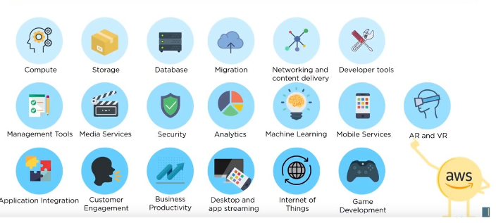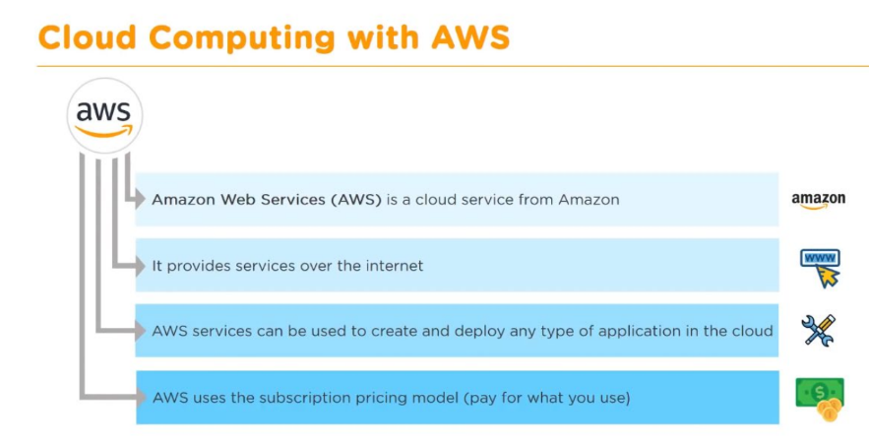

**AWS**

* Example: Netflix utilizes this
  + Media files stored in S3 (like storage)
  + Transcoding to target devices like iPad using EC2 (like computer vm)
  + Netflix has more than 100m members across 190 countries.
  + Uses AWS for nearly all computing and storage needs.
  + Especially during these times the service still remains same even with huge influx of people cause of AWS framework! Netflix makes money, so does AWS. Scalable
* AWS in terms of Netflix offers IAAS, but also has SaaS
  + Customer can interact with SW itself. Customer Doesn’t care about what goes inside cloud itself for example
  + AWS has the most variety of services at the moment, no one will probably beat it
* In this section looking at EC2, S3, Analytics (EMR)
  + EC2 and S3 we need to use these to use EMR 10:15

S3

* Like service dropbox provides and beyond
* Cloud Storage
  + Provides web service where data can be stored, accessed, and easily backed up by users over internet
  + S3 (simple storage service)
    - Provides object storage that’s built for storing and recovering any anmount of info/data anywhere
    - Durable, low cost, scalable, available, secure, flexible
* Essentially type of storage, dif storage depending on read write frequencies.
* 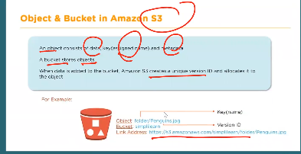 Stores Objects
  + Consists of data, assigned name (key), and metadata
* Objects stored in a bucket
* Blackboard actually uses S3 AWS
  + CPP customer of BB
  + BB uses S3 AWS as backend storage
* Folder=bucket interesting idea…
  + Inside bucket have multiple objects which are essentially files with unique key.name and meta data etc within bucket
* 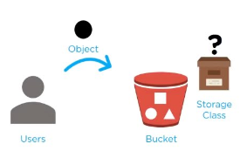22 slide shows how to create bucket
* How does it work?
  + Files uploaded to bucket, user will specify type of S3 storage class to be used for those objects
  + 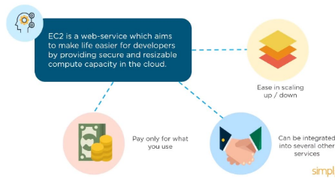User can define features to bucket like bucket policy, lifecycle policy, version control, etc

**EC2**

* Web service providing secure and resizable compute capacity in cloud
* Whenever create EC2 instance, a new vm on the hypervisor.
* Hundreds of thousands of racks across dif states, countries for AWS that Amazon runs.
* Conceptually like running virtual box running Cloudera
  + When create EC2 instance on AWS account, similar
  + So when access EC2 we either use
    - Username password to authenticate urself to AWS and use it
    - Use public key cryptography